

|  |  |
| --- | --- |
|  | Web App – Kidoz (E-commerce Website) |
|  | Lecturer’s Name: Obinna Izima.  Course Code: B9IS109 Web Development for Information Systems (B9IS109_2021_TMD2). |
|  | Student Name: Nupur Kiranrao Sonve.  Student Number: 10552432.  Date: 25 April, 2021. |

Table of Contents.

1.0. Introduction 3

2.0. Research and Planning. 3

3.0. Frameworks used in Kidoz. 3

3.1. Front-end. 3

3.2 Back-end. 4

4.0 UX 5

5.0 Web services used in Kidoz 7

6.0 Security Feature used in Kidoz 7

7.0 Conclusion 8

8.0 GitHub Link 8

9.0 Bibliography 9

List of illustrations.

Fig. 4.0. Homepage 5

Fig. 4.1. About us and contact us. 6

Fig. 4.2 Sign in/Sign up. 6

Fig. 4.3 Webapp pages. 7

1. Introduction.

A web application is described as a dynamic HTTP-based application whose intercommunications are responsive to computer processing. A web application is where users can interact with the application as it also has authentication processes like login and sign up (Hadley, 2006).

The report consists of detailed information about the web application called Kidoz. Kidoz is a toy store for kids where users can browse the toys and they can add the toys they like to their shopping cart and pay using the online payment method used by the web application. This web app is built utilizing the most developed and recommended frameworks and technologies that is been accepted globally.

1. Research and Planning.

Before creating this web app proper research was done on the process for creating the web application, how the web app should be. The structure of the web app was designed according to the specifications of the users discovered on the internet.

The study also comprises the selection of framework used to improve the web app then designing the structure and choosing the cloud platform to deploy. Furthermore, studying which security measures to be practiced in the web app to protect it from web hackers.

planning was done to create this web app. Beginning with designing the front-end using the common frameworks and most nocturnal tools, the following started to create the database for the web app. Later on, used the coding languages to combine the front-end and the back-end and picked the most reliable cloud platform to deploy the web application.

1. Frameworks used in Kidoz.

For building the Kidoz (web app), frameworks utilized are thoroughly studied and are also adopted globally. This is split into two segments: the front-end and the back-end segment. The frameworks used in front-end are mentioned in section 3.1. and frameworks used in back-end are mentioned in section 3.2.

* 1. Front-end
* **HTML**- HyperText Markup Language (HTML) is used for developing the front-end, it is worldwide used to build web applications and websites (Larsen, 2013). It is divided into three sections: the title of the web page, the main body where the content is inserted, and the footer.
* **CSS**- Cascading Style Sheets (CSS) is applied to design the document which is composed in HTML (Larsen, 2013). In Kidoz CSS is used for designing the menu bar, changing the colour of the text, padding between the menu options, creating a grid layout for displaying the toys in the shop menu.
* **Bootstrap**- Bootstrap is a free front-end framework that is used universally to build a responsive web application, websites, or mobile apps (Efron, Tibshirani, 1994). Almost all the software programmers used it to create their applications responsively. Whether it is a small mobile phone, a tablet, laptop, or a desktop it automatically adjusts with the screen size.
* **jQuery**- jQuery is a **JavaScript** library that offers a development environment of basic web programming for specific purposes and beneficial for nearly any programming scenario. The library gives an interesting method to intercept many actions, including clicks on some kind of page, without seizing the HTML code. Simultaneously, its API eliminates interface glitches which sometimes annoy the developers (Chaffer, Swedberg, 2011).

jQuery is used by most of the web developers because it performs the operations by writing fewer lines of code, comparing with other libraries. In Kidoz, jQuery is used for responding to user's interaction such as to call the action when the user clicks on any buttons like shop, contact us.

* 1. Back-end
* **MVC**- The Model View Controller (MVC) is a structure that divides a web application further into three major segments: the model, the view, and the controller. MVC is an industry-standard web developing platform that is one of the most used to build flexible and customizable applications (Deacon, 2009). In simplistic terms, the model consists of the back-end component the view consists of the front-end component and the controller acts as a connection between model and view.
* **MySQL**- It is a relational database management system. The application is utilized for a broad diversity but mainly it is utilized for web application databases. This database is extremely speedy and manageable to utilize so most web developers favour this. It also recognizes the structured language query (SQL) which is adopted by the most utmost advanced database systems. Including it has an outstanding capacity where numerous users can join at the very same time without any glitches also it provides added features which makes it extremely effective for developers to adopt it (DuBois, 2008). So, considering these features Kidoz uses MySQL database to store user data.
* **PYTHON**- Python is a coding language that delivers all the functions alike other coding languages like HTML, CSS, JavaScript. It is additionally used for developing web applications. It is also preferred by developers globally.
* **FLASK**- Flux Advanced Security Kernel (FLASK), is a light web framework that is written in python. Nowadays, most maximum of the web applications that are been developed or developing is using flask as it is simple and gives the easiest solutions for the complicated code line (Grinberg, 2018). As an advantage, it has an extremely robust set of libraries that attracts web developers to utilize it. Furthermore, Flask is straightforward to study so keeping this in mind Kidoz utilizes flask for the back-end.
* **Stripe**- Stripe is a digital payment processing app that enables enterprises to transfer and accept payments across the internet, also it is adopted by many big companies which are globally recognized. So, in Kidoz, a stripe payment gateway is used to get accept money from the customers.

1. UX

User experience (UX) is the interaction of users with the website and this project involves different technologies to make UX more attractive, convenient, and fast to use for users. The "[Kidoz](http://34.244.137.44/)" web app is designed according to a responsive structure for users.

This is the homepage of the webapp. <http://34.244.137.44/>

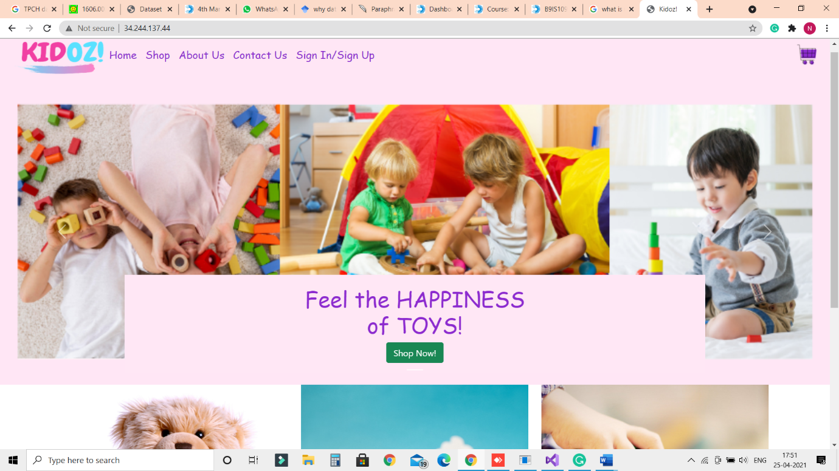

*Fig. 4.0. Homepage.*

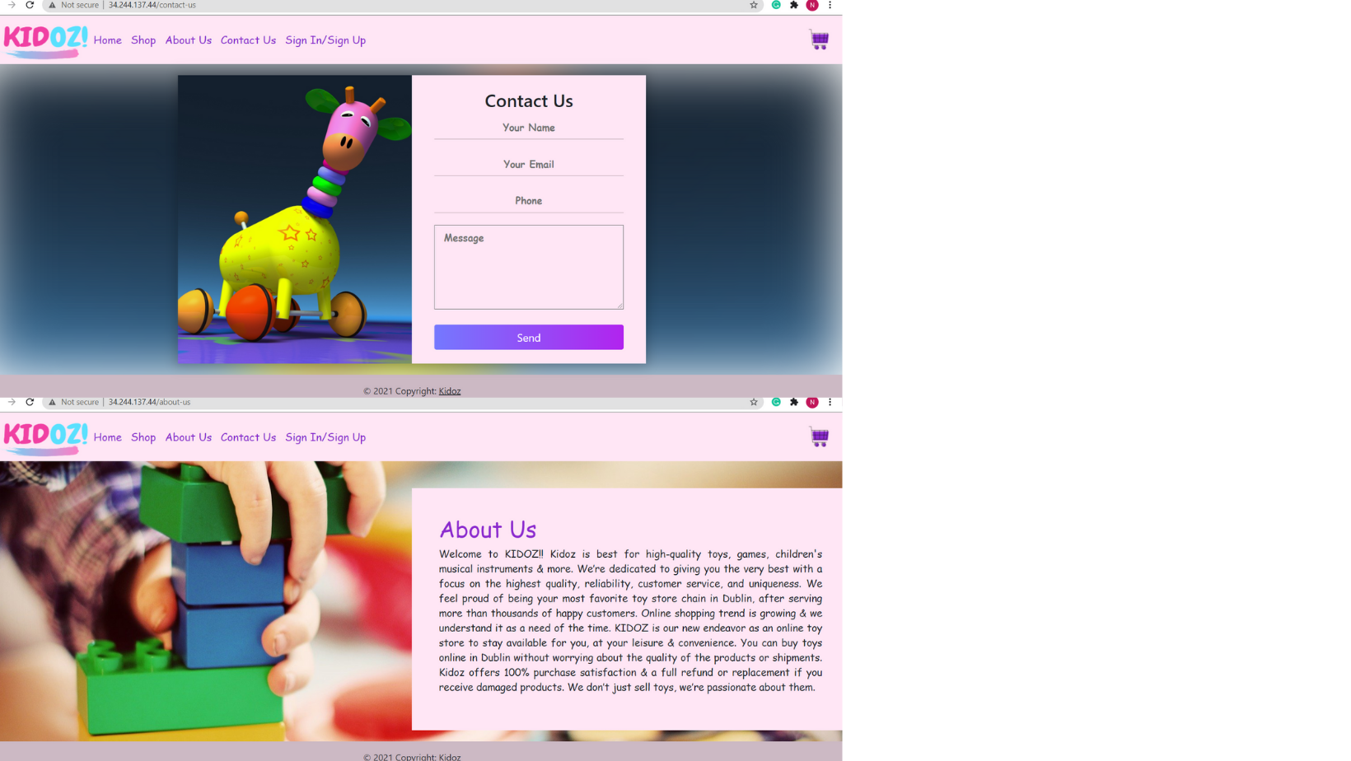

*Fig. 4.1. About us and contact us.*

When use visits the webapp they can see Home, Shop, About Us, Contact Us, Sign In/ Sign Up options in the navigation bar in the top of the webpage. User select the contact us option to contact the team of the shop and also, they can see the detail description of the shop on the about us page.

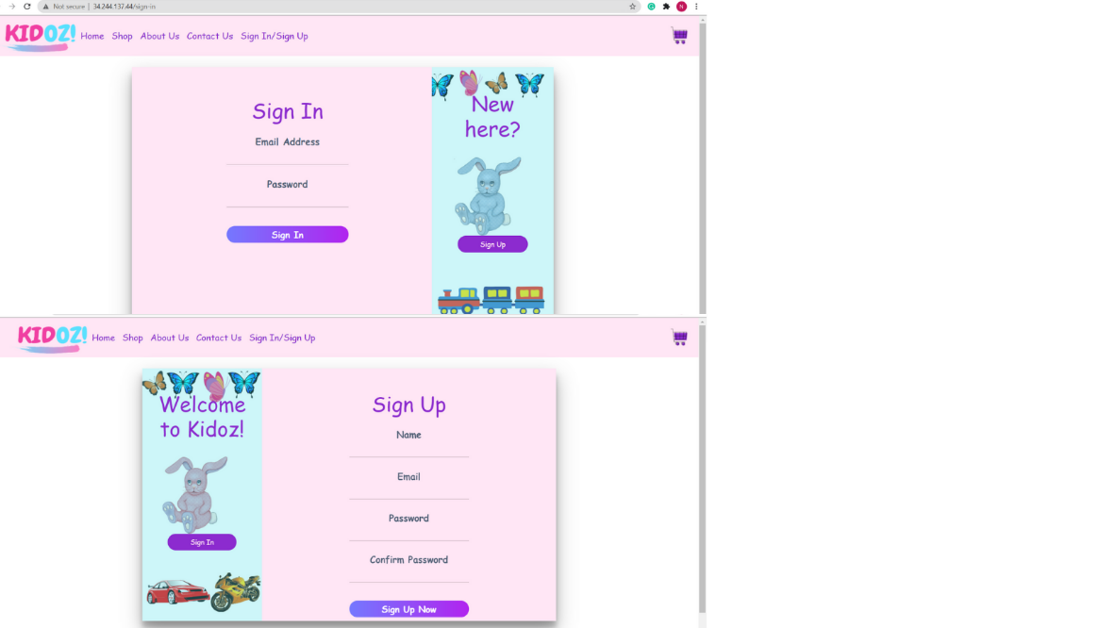

*Fig. 4.2. Sign in/Sign up.*

This is the sign in and sign-up page for users. Users have to sign up using credentials like name, email and password to buy toys from the website. If they have already registered then they just have to put login credentials to browse the website.

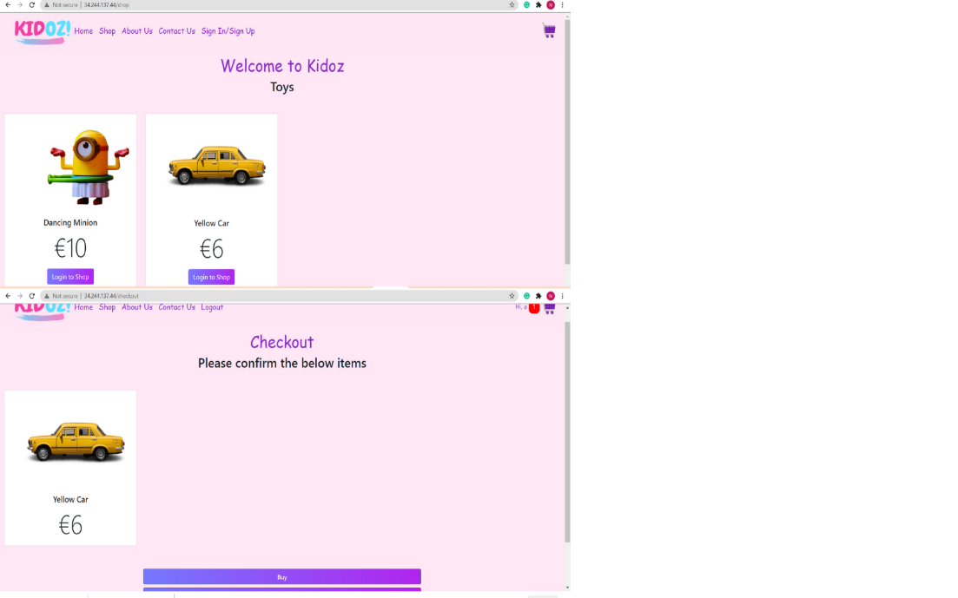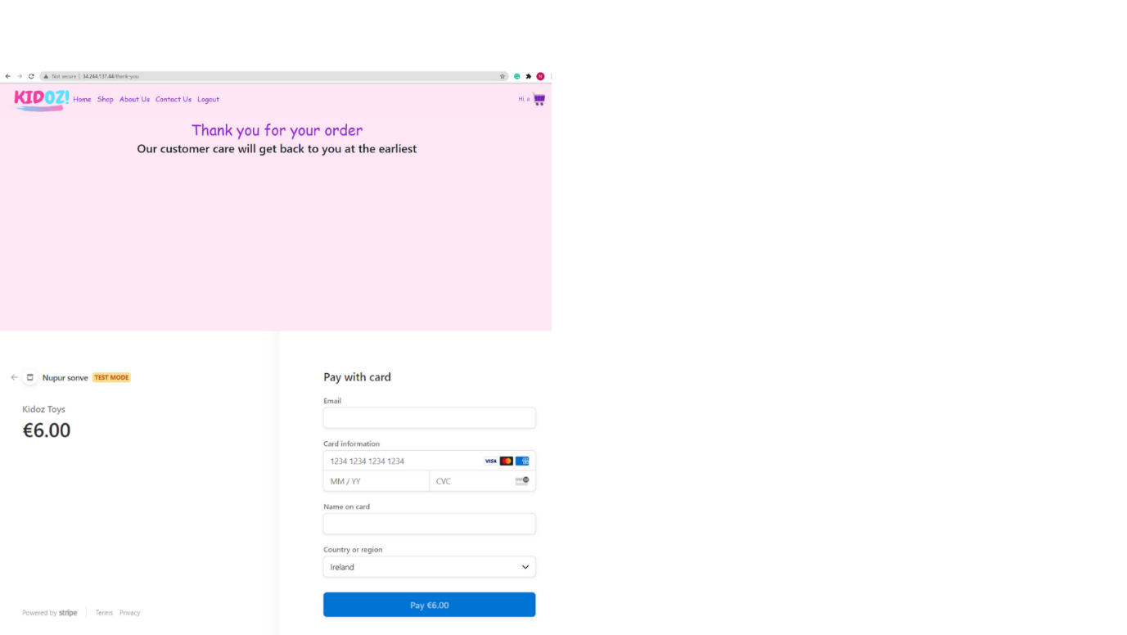

*Fig. 4.3. webapp pages.*

Users can select the shop button from the navigation bar and they will redirect to the shopping page. Users can select the product they like and can add to the cart. After adding product into the cart user will redirect to the checkout page. When users will click on the buy button, they they will redirect to payment page. User have to put their valid card details for further payment. If the payment is successful, they can see the “Thank you for your order” message.

1. Web Services used in Kidoz.

Amazon Web Services grants a wide set of cloud-based products including cloud storage, database, networking, developer tools, IoT, network security, business applications, and many more. All of the services assist companies to move faster, reduce IT expenses, Aws is straightforward to employ, Adjustable, available at a low price, trustworthy, marvellous performance as well as it is secure and safe. Nearly all web developers and large businesses use AWS because it provides superior consumer assistance. Aws provides one year of free subscription so Kidoz was deployed using this cloud platform. Amazon EC2 (Elastic compute cloud) comprises of all the front-end part whereas Amazon RDS (Relational database service) contains the database part (Amazon, 2015).

web application Kidoz is not secure right now, but in future a domain name and SSL certificate can be installed to make it active in the real world for the users.

1. Security feature used in Kidoz.

Security is always the priority of any software programmer for building applications. Web application protection is the method of defending websites and web applications against various security threats that misuse vulnerabilities in a web application (Li, Xue, 2011).

While creating Kidoz three security features have taken into consideration and have been implemented.

* Similar to cookies, there is a security feature called session data in a python flask that saves the user information on the server, as well as tracks the activity of the user.
* Kidoz also uses SQLAlchemy which is utilized to interact between python code and the database. It also takes care of the SQL injection.
* Including, one more security feature is applied in Kidoz is IP whitelisting, which is executed on the AWS server, where just the chosen users whose IP has been whitelisted can access the database.

1. Conclusion.

This project helped me in learning new technologies also working on the design of the web app I was able to improve my web development skills and knowledge. This web app is user-friendly, responsive, and attractive.

The project mainly involves the modern framework for interactive front-end for users, different web services, and various technologies.

The main aim of this web app is that users can shop online easily from home. Overall, [Kidoz](http://34.244.137.44/) is a web app for kids, and they can buy different toys from the website.

1. GitHub Link

1. Bibliography.
2. Hadley, M.J., 2006. Web application description language (WADL).
3. Larsen, R., 2013. Beginning HTML and CSS. John Wiley & Sons.
4. Chaffer, J. and Swedberg, K., 2011. Learning jQuery. Packt Publishing Ltd.
5. Deacon, J., 2009. Model-view-controller (mvc) architecture. Online][Citado em: 10 de março de 2006.] http://www. jdl. co. uk/briefings/MVC. pdf.
6. DuBois, P., 2008. MySQL. Pearson Education.
7. Grinberg, M., 2018. Flask web development: developing web applications with python. " O'Reilly Media, Inc.".
8. Amazon, E.C., 2015. Amazon web services. Available in: http://aws. amazon. com/es/ec2/(November 2012).
9. Li, X. and Xue, Y., 2011. A survey on web application security. Nashville, TN USA, 25(5), pp.1-14.
10. Efron, B. and Tibshirani, R.J., 1994. An introduction to the bootstrap. CRC pres